

**Static Code Analyser Tool**

**Mini-Project Synopsis**

*submitted to*

Manipal School of Information Sciences, MAHE, Manipal

|  |  |  |
| --- | --- | --- |
| **Reg. Number** | **Name** | **Branch** |
| **241059027** | **Anusha S Patil** | **CYS** |
| **241059032** | **K Anusha Rao** | **CYS** |
| **241059033** | **S Srinivas** | **CYS** |

**26/01/2025**



**Table of Contents**

1. **Project Description**
2. **Objectives**
3. **Literature Survey**
4. **Block Diagram/Flowchart**
5. **Applications**
6. **Software & Hardware Requirements**

**References**

**Project Description**

Good code quality is a fundamental need in today’s modern world. Since source code is used universally to develop every software that runs on an electronic device, it is essential that source code must be well written and maintained in order to handle updates and enhancements.

When a software developer or code security analyst needs to analyse source code to detect security flaws and maintain secure, high-quality code, manual review may not uncover all issues. Even experienced security analysts can overlook vulnerabilities. A source code analysis tool addresses this challenge by automatically and efficiently identifying potential security flaws without executing the code. It serves as a reliable complement to manual inspection, enhancing accuracy and thoroughness. A Static Code Analyser is a software tool that examines source code for potential errors, vulnerabilities, and adherence to coding standards without executing the program. This report provides an in-depth view of a Python-specific static code analyser, detailing its architecture, functionality, and use in maintaining high-quality Python projects.

**Objectives**

* Identify Common Code Defects and Vulnerabilities.
* Develop a Basic Static Code Analysis Tool.
* Provide an interface for users to upload, scan, and review code analysis reports.

**Literature Survey**

The literature survey gives a brief overview about the various security vulnerabilities which can be detected by a Static code Analyser and also the existing tools available.

|  |  |  |  |  |
| --- | --- | --- | --- | --- |
| Paper Title | Author(s) | Summery | Tools | Future Scope |
| Evaluating Python Static Code Analysis Tools Using FAIR Principles | H. B. Hassan, Q. I. Sarhan and Á. Beszédes | Evaluates Python static analysis tools using FAIR principles to enhance usability. | Prospector, Pylint, SonarQube, Pynocle etc | Create a user-friendly web application allowing developers to choose and evaluate static code analysis tools based on their specific programming languages and analysis needs |
| Static Code Analyser to Enhance Developer Productivity | D. R. I. Peiris and N. Kodagoda | Developed a tool to improve coding practices and developer productivity through static analysis. Used Abstract Syntax Trees to build the analyser. | Nil | Improve the algorithm to handle issues such as tightly coupled code, collusion etc. A.I and ML based learning could be integrated to enhance the value of this software by sniffing issues using prediction-based learning. |
| Towards More Sophisticated Static Analysis Methods of Python Programs | H. Gulabovska and Z. Porkoláb | Investigates advanced static analysis methods like symbolic execution compared to traditional ones. | CodeSonar, Klocwork, Coverity, PyLint, Pyflakes | Symbolic execution-based analyser tools for Python can use powerful SAT solvers, such as Z3. |
| Static Type Analysis for Python | T. Dong, L. Chen, Z. Xu and B. Yu | Developed a tool, PType, to make type analysis including constructing a type system, preprocessing the source code, making type annotations for classes, functions and built-in modules, making type inference based on constraint graph. | PType | Expand type checking capabilities and integrate with other tools. |
| A Large-Scale Security-Oriented Static Analysis of Python Packages in PyPI | J. Ruohonen, K. Hjerppe and K. Rindell | Examines security issues in Python packages using static analysis to identify vulnerabilities. | Bandit | Software metrics can be collected to make the simple predictive approach more interesting theoretically. Longitudinal analysis is required for assessing the robustness of the effects reported. |

**Block Diagram/Flowchart**

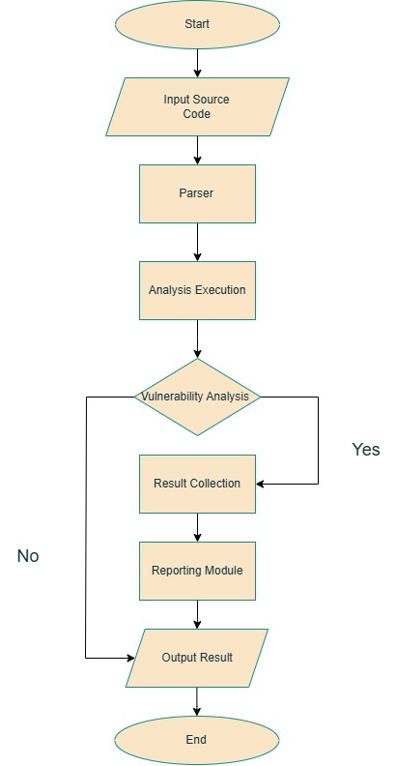

**Applications**

* **Immediate Feedback on Code Issues:** Source code analysis tools, also known as SAST tools, provide instant feedback to developers, helping them address vulnerabilities and errors early in the development process rather than later in the Software Development Life Cycle (SDLC).
* **Improved Code Quality from the Start:** These tools encourage developers to focus on creating secure and high-quality code right from the beginning, reducing the risk of introducing security flaws during development.
* **Cost-Effective Solutions for Security:** While many commercial tools are expensive, there are free and open-source static code analysis tools available, making them ideal for startups and freelancers who need robust security solutions without breaking the budget.
* **Wide Adoption Across Industries:** Due to the increasing demand for secure coding practices, these tools are widely adopted across organizations, ranging from individual developers to large enterprises, to ensure code safety and compliance with standards.

**Software & Hardware Requirements**

**Hardware Requirements**

|  |  |
| --- | --- |
| Processor | Dual-core CPU (e.g., Intel Core i3 or higher) |
| RAM | 4 GB |
| Disk Space | 10 GB |

## **Software Requirements**

|  |  |
| --- | --- |
| OS | Windows, Linux |
| IDE | VS Code |
| Plugins | PyLint |

**References**

1. H. B. Hassan, Q. I. Sarhan and Á. Beszédes, "Evaluating Python Static Code Analysis Tools Using FAIR Principles," in IEEE Access, vol. 12, pp. 173647-173659, 2024, doi: 10.1109/ACCESS.2024.3503493.
2. D. R. I. Peiris and N. Kodagoda, "Static Code Analyser to Enhance Developer Productivity," 2023 IEEE 8th International Conference for Convergence in Technology (I2CT), Lonavla, India, 2023, pp. 1-6, doi: 10.1109/I2CT57861.2023.10126395.
3. H. Gulabovska and Z. Porkoláb, "Towards More Sophisticated Static Analysis Methods of Python Programs," *2019 IEEE 15th International Scientific Conference on Informatics*, Poprad, Slovakia, 2019, pp. 000225-000230, doi: 10.1109/Informatics47936.2019.9119307.
4. T. Dong, L. Chen, Z. Xu and B. Yu, "Static Type Analysis for Python," *2014 11th Web Information System and Application Conference*, Tianjin, China, 2014, pp. 65-68, doi: 10.1109/WISA.2014.20.
5. J. Ruohonen, K. Hjerppe and K. Rindell, "A Large-Scale Security-Oriented Static Analysis of Python Packages in PyPI," in 2021 18th International Conference on Privacy, Security and Trust (PST), Auckland, New Zealand, 2021, pp. 1-10, doi: 10.1109/PST52912.2021.9647791.